**Year 12 Human Biology**

**Unit 3: Science Inquiry – Biotechnology and Evidence for Evolution (5%)**

**NAME: ________________________**

**Teacher: Mrs Cunningham  
  
Task 10** Validation: **/55**

**TYPE:** Science Inquiry

**CONTENT:** Biotechnology and Evidence for Evolution

**TIME:** 60 minutes

**Evidence for Evolution & Biotechnology Validation**

Genome sequencing involves determining the complete DNA sequence of an organism’s nuclear and mitochondrial DNA. For this investigation, 5 of each species’ mitochondrial genomes were sequenced.

This can be used to determine the relationship between Humans and Rhesus macaques, Pygmy chimpanzees, Gorillas, Japanese monkeys and Bush babies, by comparing their mitochondrial genome size.

**Question 1 (4 marks)**

1. Describe the aim of this investigation. (1 mark)

______________________________________________________________________________

______________________________________________________________________________

______________________________________________________________________________

1. Name the specific dependent variable for this investigation. (1 mark)

______________________________________________________________________________

1. Write a suitable hypothesis for this investigation. (2 marks)

______________________________________________________________________________

______________________________________________________________________________

______________________________________________________________________________

______________________________________________________________________________

**Question 2 (11 marks)**

The results from this investigation are below. Use Figure 1 to answer parts a) to d) below.

**Figure 1: Mitochondrial genome size of humans compared to primates**

|  |  |  |
| --- | --- | --- |
| Scientific name | Common name | Genome size (base pairs) |
| *Homo sapiens* | Human | 16,500 |
| *Macaca mulatta* | Rhesus monkey | 17,092 |
| *Pan paniscus* | Pygmy chimpanzee | 16,500 |
| *Gorilla beringei* | Gorilla | 16,405 |
| *Macaca fuscata* | Japanese monkey | 17,000 |
| *Galagidae* | Bush baby | 16,500 |

Sources of genome data: Brown et al. (1979); Ferris et al. (1981); George (1982); Hayasaka et al (1986); Harihara et al. (1986).

1. Draw a phylogenetic tree to represent these results. (2 marks)
2. Write a suitable conclusion for this investigation. (2 marks)

______________________________________________________________________________

______________________________________________________________________________

______________________________________________________________________________

______________________________________________________________________________

______________________________________________________________________________

1. Based on the information provided, is this investigation reliable? Justify your response and describe how this investigation could be improved. (3 marks)

______________________________________________________________________________

______________________________________________________________________________

______________________________________________________________________________

______________________________________________________________________________

______________________________________________________________________________

Comparative studies of anatomy also provide evidence for evolutionary change over time.

1. Name and describe one (1) aspect of comparative anatomy, include how this would support the data from Figure 1 above. (4 marks)

______________________________________________________________________________

______________________________________________________________________________

______________________________________________________________________________

______________________________________________________________________________

______________________________________________________________________________

______________________________________________________________________________

______________________________________________________________________________

______________________________________________________________________________

**Question 3 (11 marks)**

Biotechnological techniques such as PCR and gel electrophoresis allow for the rapid analysis of multiple samples of DNA.

1. Describe the function of each of the following in gel electrophoresis of DNA.
2. Agarose gel: (1 mark)

______________________________________________________________________________

______________________________________________________________________________

1. Electric current: (1 mark)

______________________________________________________________________________

______________________________________________________________________________

1. Outline what would happen to the DNA fragments if you forgot to turn the current off. (1 mark)

______________________________________________________________________________

______________________________________________________________________________

1. Describe how different sized DNA fragments are separated by the gel matrix. (2 marks)

______________________________________________________________________________

______________________________________________________________________________

______________________________________________________________________________

______________________________________________________________________________

Recombinant DNA involves combining sources of DNA from two different sources and is used in genetic engineering.

Parts (d) – (g) of this question refers to the diagram below, which outlines how synthetic insulin is produced.

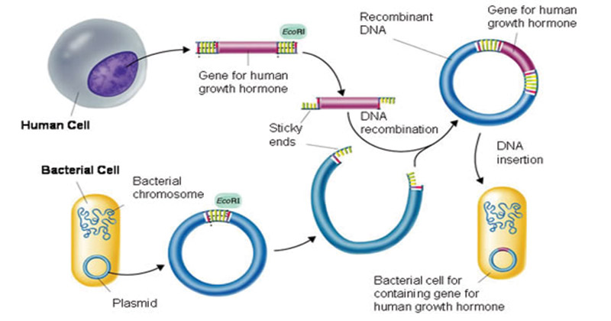

**A**

**C**

**D**





**B**

1. Name structure A in the diagram above. (1 mark)

___________________________________________________________________

1. Describe what occurs at B in this scenario. (2 marks)

___________________________________________________________________  
___________________________________________________________________  
___________________________________________________________________  
___________________________________________________________________

1. Describe what occurs to enable C to be produced. (2 marks)

___________________________________________________________________  
___________________________________________________________________  
___________________________________________________________________  
___________________________________________________________________

1. State the function of structure D. (1 mark)

___________________________________________________________________  
___________________________________________________________________

**Question 4 (5 marks)**

Examine the diagram of a gel below and answer parts a) to e).

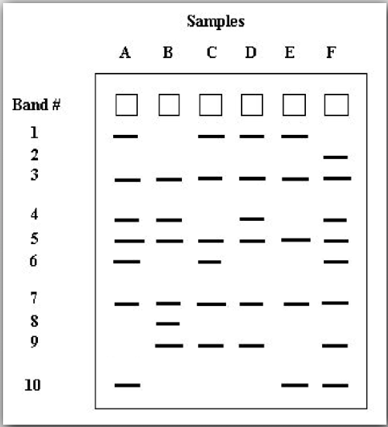

1. Outline what the bands in the drawing above represent. (1 mark)

______________________________________________________________________________

______________________________________________________________________________

1. Name the band(s) which travelled slowest. (1 mark)

______________________________________________________________________________

1. On the above drawing, label the positive and negative ends of the gel. (1 mark)
2. Determine how many bands are shared in common by all of the individuals. List the common bands. (1 mark)

______________________________________________________________________________

1. Determine if there any bands which are unique to only one individual. If so, which one/s?

(1 mark)

______________________________________________________________________________

______________________________________________________________________________

**Question 5 (5 marks)**

Orangutans are an endangered species of ape that live in Southeast Asia. Their numbers have dwindled due to habitat loss and poaching, but there are currently efforts to save the orangutans.

DNA fingerprinting has been used by Dr. Benoit Goossens at Cardiff University to better understand mating and genetic variation in orangutans.

Mother baby Male 1 Male 2



1. Use the diagram above to determine who the father is of the baby orangutan. (1 mark)

______________________________________________________________________________

1. Explain how you reached this conclusion using evidence from the DNA fingerprint. (2 marks)

______________________________________________________________________________

______________________________________________________________________________

______________________________________________________________________________

______________________________________________________________________________

______________________________________________________________________________

______________________________________________________________________________

1. Explain what is meant by DNA profiling/fingerprinting, and how it is different to DNA sequencing. (2 marks)

______________________________________________________________________________

______________________________________________________________________________

______________________________________________________________________________

______________________________________________________________________________

______________________________________________________________________________

______________________________________________________________________________

**Question 6 (19 marks)**

1. Describe the purpose of PCR. What role does electrophoresis play in this process? (2 marks)

______________________________________________________________________________

______________________________________________________________________________

______________________________________________________________________________

______________________________________________________________________________

1. Describe the structure and function of a primer. (3 marks)

______________________________________________________________________________

______________________________________________________________________________

______________________________________________________________________________

______________________________________________________________________________

______________________________________________________________________________

1. Describe what Taq polymerase is and outline its function. (2 marks)

______________________________________________________________________________

______________________________________________________________________________

______________________________________________________________________________

______________________________________________________________________________

1. List the three stages in PCR and describe what occurs at each stage. (6 marks)

______________________________________________________________________________

______________________________________________________________________________

______________________________________________________________________________

______________________________________________________________________________

______________________________________________________________________________

______________________________________________________________________________

______________________________________________________________________________

______________________________________________________________________________

______________________________________________________________________________

______________________________________________________________________________

1. Explain why a water sample placed in the thermocycler (PCR machine) alongside the DNA sample. (2 marks)

______________________________________________________________________________

______________________________________________________________________________

______________________________________________________________________________

______________________________________________________________________________

1. Name any four of the reagents in the Master Mix or PCR mix. (2 marks)

______________________________________________________________________________  
  
______________________________________________________________________________

1. Describe the structure and function of a DNA ladder. (2 marks)

______________________________________________________________________________

______________________________________________________________________________

______________________________________________________________________________

______________________________________________________________________________